AI ASSISTED CODING
ENROLL NUMBER: 2403A52400
BATCH NUMBER :14
Lab assignment-7.3
Task1:
Paste a function with a missing colon (add(a, b)), and let AI fix the syntax error.
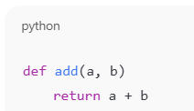
Code output:
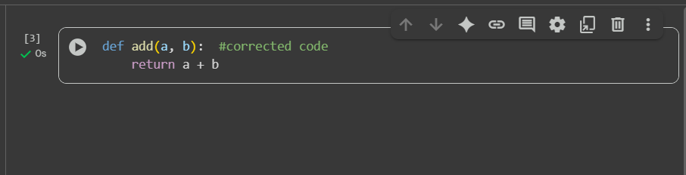
Code explanation:
The error message SyntaxError: expected ':' indicates that there is a missing colon after the function definition def add(a, b). Additionally, the return statement needs to be indented to be part of the function body. I will fix these errors in the code.
I've fixed the syntax error and the indentation in the add function. You can now use this function to add two numbers. Would you like to test it with some examples? Or perhaps you have another task in mind?

Task2:
- Identify and fix a logic error in a loop that causes infinite iteration.
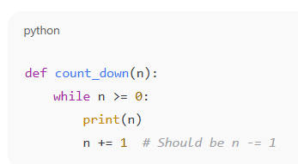
Code output:
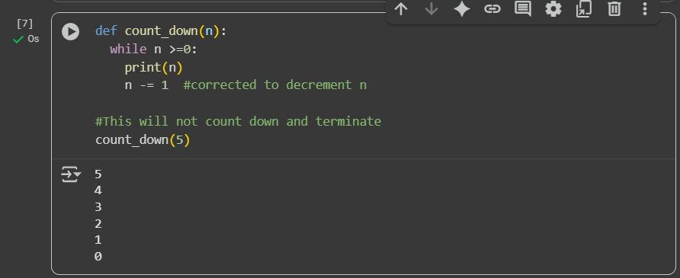
Code explanation:
Certainly! I can explain the code you provided.
def count_down(n):
while n >=0:
print(n)
n -= 1
This code defines a function called count_down that takes one argument, n.
- def count_down(n):: This line defines a function named count_down that accepts a single parameter n.
- while n >= 0:: This is a while loop that continues to execute as long as the value of n is greater than or equal to 0.
- print(n): Inside the loop, this line prints the current value of n to the console.
- n -= 1: This line decrements the value of n by 1 in each iteration of the loop. This is what makes the number count down.
#This will not count down and terminate
count_down(5)
This part of the code calls the count_down function with the argument 5. So, the function will start counting down from 5, printing each number until it reaches 0.
The comment #This will not count down and terminate seems to be a remnant from a previous version of the code, as the current code does count down and terminate when n becomes less than 0.
0 / 2000

Task3:
Debug a runtime error caused by division by zero. Let AI insert try-except.
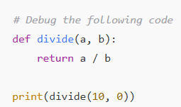

Code output:
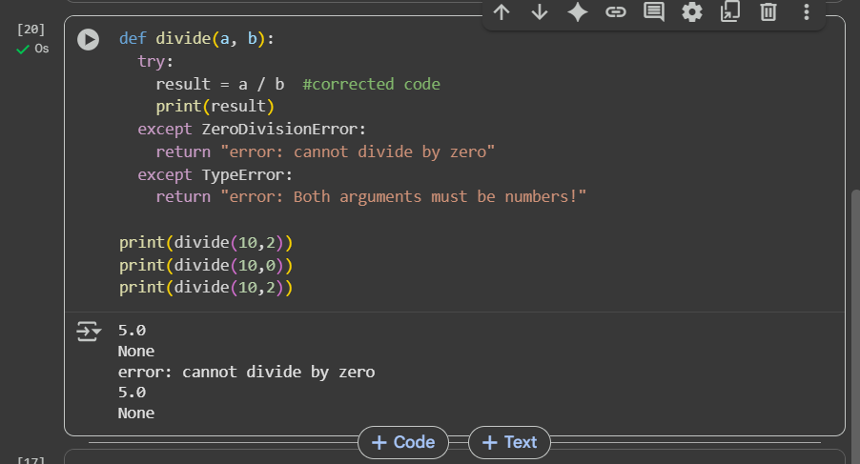

Code explanation:
The error in the selected cell is a ZeroDivisionError, which occurs when you try to divide a number by zero. This is mathematically undefined and therefore causes an error in programming. I will modify the code to include a check for division by zero and print an error message if it occurs.
I have successfully modified the divide function to handle division by zero by adding a check. You can now test the function with different inputs, including cases where b is not zero, to see the correct division results.
0 / 2000

Task4:
Provide a faulty class definition (missing self in parameters). Let AI fix it
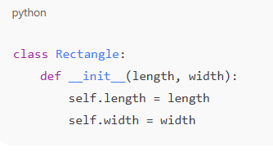

Code output:
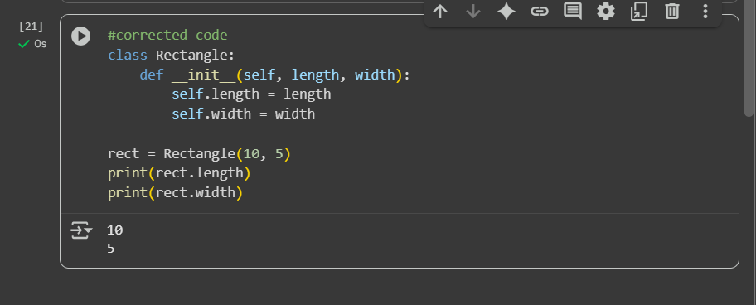
Code explanation:
I can explain this code for you.
This code defines a simple class called Rectangle and then creates an object (an instance) of that class.
class Rectangle:
def __init__(self, length, width):
self.length = length
self.width = width
- class Rectangle:: This line defines a new class named Rectangle. Classes are blueprints for creating objects that have specific properties (attributes) and behaviors (methods).
- def __init__(self, length, width):: This is a special method called the constructor. It's automatically called when you create a new object of the Rectangle class.
  - self: This refers to the instance of the class being created. It's a convention to use self as the first parameter.
  - length and width: These are parameters that you pass when you create a Rectangle object.
  - self.length = length: This line takes the value passed for the length parameter and assigns it to an attribute of the object called length.
  - self.width = width: Similarly, this line takes the value passed for the width parameter and assigns it to an attribute of the object called width.
In essence, the __init__ method initializes the attributes of a Rectangle object when it's created.
rect = Rectangle(10, 5)
print(rect.length)
print(rect.width)
- rect = Rectangle(10, 5): This line creates a new instance of the Rectangle class. It calls the __init__ method with 10 for length and 5 for width. The newly created Rectangle object is assigned to the variable rect.
- print(rect.length): This line accesses the length attribute of the rect object and prints its value (which is 10).
- print(rect.width): This line accesses the width attribute of the rect object and prints its value (which is 5).
So, the code defines what a Rectangle is (it has a length and a width) and then creates a specific rectangle with a length of 10 and a width of 5, and finally prints those dimensions

Task5:
Access an invalid list index and use AI to resolve the Index Error.
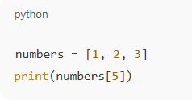

Code output:
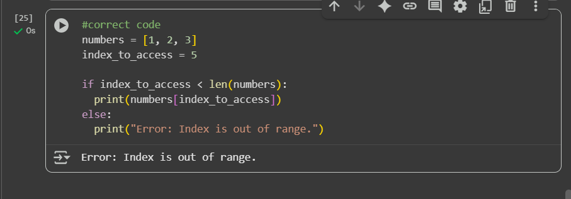

Code explanation:
The code in the selected cell has two errors. First, there's a SyntaxError: expected ':' because the else statement is missing a colon at the end. Second, even if the syntax error is fixed, there will be an IndexError: list index out of range because you are trying to access an index (5) that is outside the valid range of the numbers list (which only has indices 0, 1, and 2).
I will fix the syntax error by adding a colon to the else statement and correct the code to check if the index_to_access is within the valid range of the list before attempting to access it.
I have fixed the SyntaxError by adding the missing colon to the else statement and added a check to prevent the IndexError. The code now correctly identifies when the index is out of the list's range.
You can now try changing the value of index_to_access to a number between 0 and 2 (inclusive) to see the element at that index being printed. You could also try modifying the numbers list.

